**Name :- Devshree Rajesh Bhongade**

**Subject :- Assignment Week-8**

**Date :- 11/09/2021**

**ID :- NGP0721001**

**ASSIGNMENT-1**

Explain the architecture of Ansible along with its use case and architectural diagram.

Ans:-

Let’s first understand the meaning of architecture in term of devops. Architecture means to understand the functioning of any tools and its related terminology. How that tool works, how to give and take request from client, how to [communicate](https://docs.ansible.com/ansible/latest/dev_guide/overview_architecture.html) master with client and client with master. What are the use case of that tools and where that tool is getting fit etc. So before moving next first have a look of ansible architecture diagram.

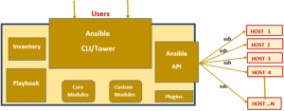

How ansible works?

In the above diagram we have taken overview of ansible architecture and its component. Now let’s learn how it works with the help of below diagram.

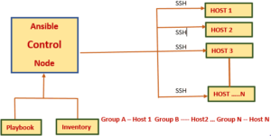

Suppose we have setup ansible control node, playbook, inventory and some client host for lab particle as shown in above diagram. Ansible control node will connect with client node with the help of ssh protocol. After connecting with client node control node will push a small program that is called ansible modules. These modules will execute on client and will complete require task. When task will complete then ansible will remove these modules from client node.

Terminology for ansible architecture

After learning ansible architecture and its work style. We should learn its basic [terminology](https://en.wikipedia.org/wiki/Ansible_(software)). That will use again and again when we will write playbooks and inventory file.

Control Node

Basically, we can say control node is our master ansible server means where we will install our ansible setup. So, now question is what will be our basic software and hardware requirement for ansible setup.

Software requirement

1. Control node should be Linux instead of Windows.
2. Version of python should be 2.6 or more then it.
3. OS version should be minimum RHEL/Centos 6 or above it.

Hardware requirement

Here I am telling about ansible cli not ansible tower. Ansible hardware requirement is depend on value of fork means number of machine or client host. Where you want to push changes at a time.4 GB RAM = 100 fork  this is production point of  view. For leaning stage 1 GB RAM, 10GB HDD, 1 CPU is enough.

Management nodes

Management nodes means those machines which we are going to manage. In simple language client machines where we are going to push our changes called management nodes. It might be Linux flavor, Windows or cloud machine. It might be device like firewall, Switch, Router etc.

Communication protocol

I thinks everyone knows about communication protocol of ansible. It use ssh protocol for communication between control node and management node.

Inventory file

Inventory is a kind of files which contains the records of manage node IP address/HostName/Password/Groups. There are two type of inventory.

Statics inventory

Statics inventory is kind of statics file. We will use statics inventory when our IP address are fix means no need to change IP address after making inventory.

Dynamic inventory

Dynamic inventory is kind of program that retrieve IP address of new provisioned machines automatically. This type of inventory will use mainly in case of cloud infra. Where machine is creating and terminating again and again.

Modules

Modules is basically kind of scripting. Suppose we want to perform any task in our infra, all information related to that task is written in modules in form of language. It might be Python, bash, shell, ruby etc. Ansible mainly supporting two type of modules.

1. Core modules :- Which is written in python language
2. Custom modules :- We will write custom modules according to our requirement in python, ruby, bash, shell or in other languages.

Learn push configuration method in ansible architecture

There are mainly two way to push our changes from control node to manage node/Client node. Let’s discuss one by one.

Playbook

We have preferred playbook where we need to perform any task on repeat basis means suppose we want to take backup of our all server, we can write a playbook for that. Playbooks are written in YAML language. In details we will discuss latter.

Ansible features

After learning ansible architecture and its terminology. Lets have a look of ansible feature.

Agentless – In ansible agentless means there is no need of  any software or agent to managing the client node like other automation tools such as puppet and chef.

SSH – Ansible use ssh protocol for client communication. Which is very secure. There is no need to open any external port for ansible.

Push architecture –  The major advantage of ansible is, it works on push architecture. Means it can push our changes parallelly on all machine as required that will save our lots of time.

**ASSIGNMENT-2**

Create 2 new ansible nodes as per below specifications

IP Host name OS

192.168.56.10 puneet-node-1 ubuntu 18.04

192.168.56.20 puneet-node-2 ubuntu 18.04

Create a single playbook to install

* apache2 on 192.168.56.10 with default webpage puneet.html with the contents “Welcome Puneet to the world of Apache with Ansible” with handlers and notify.
* nginx on 192.168.56.20

Note: Please replace the file names with your respective name in the given examples.

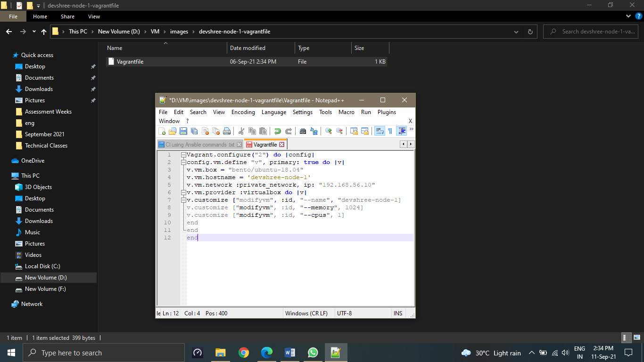

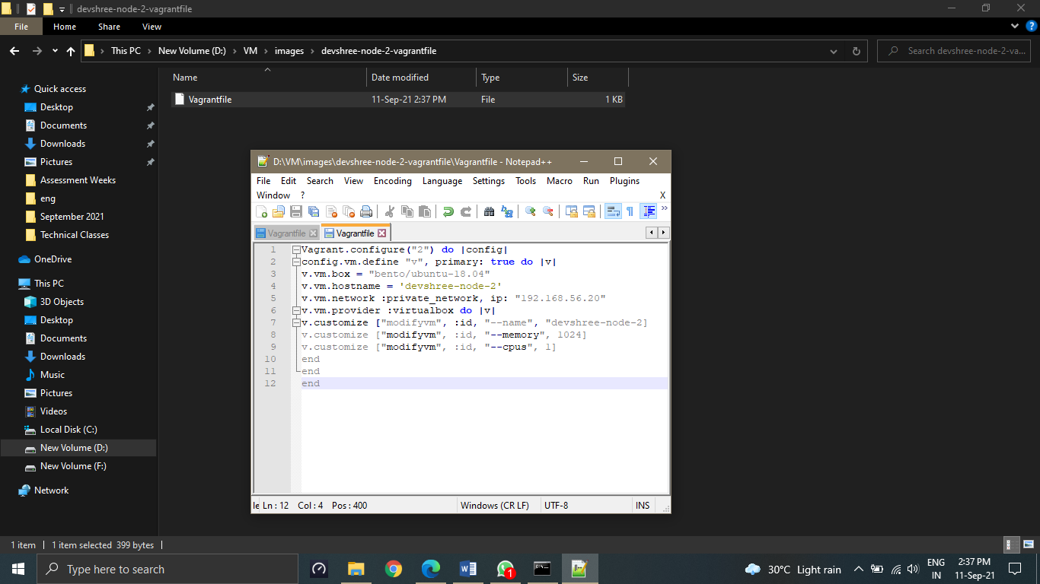

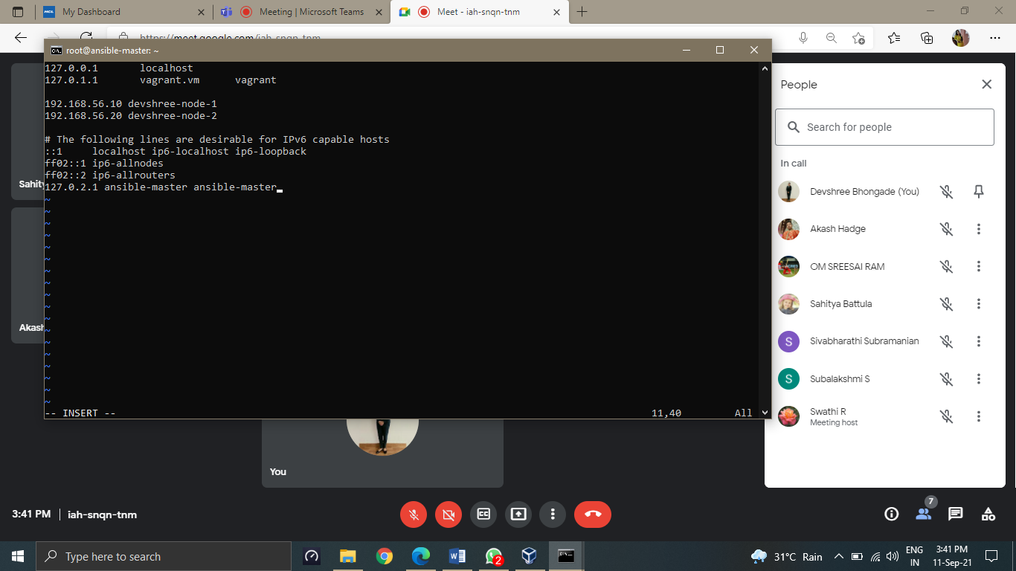

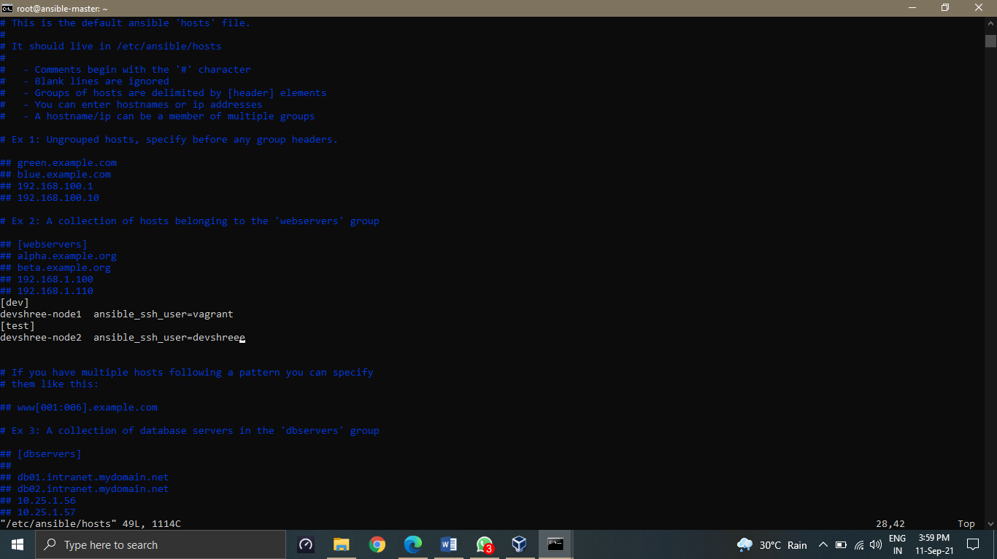

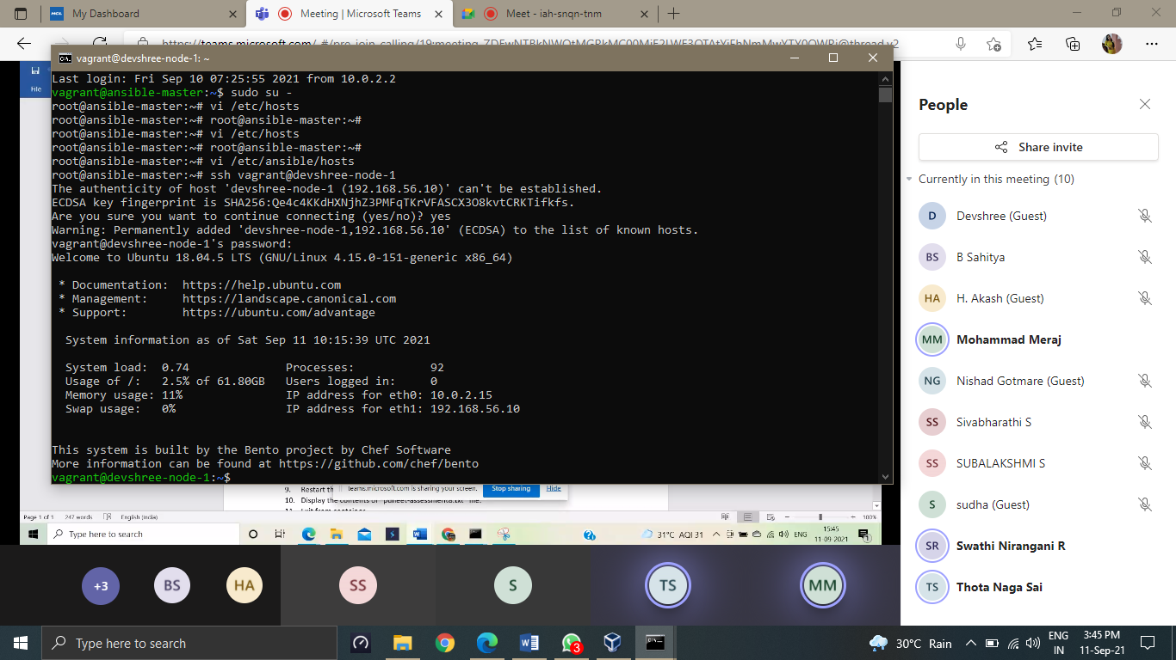

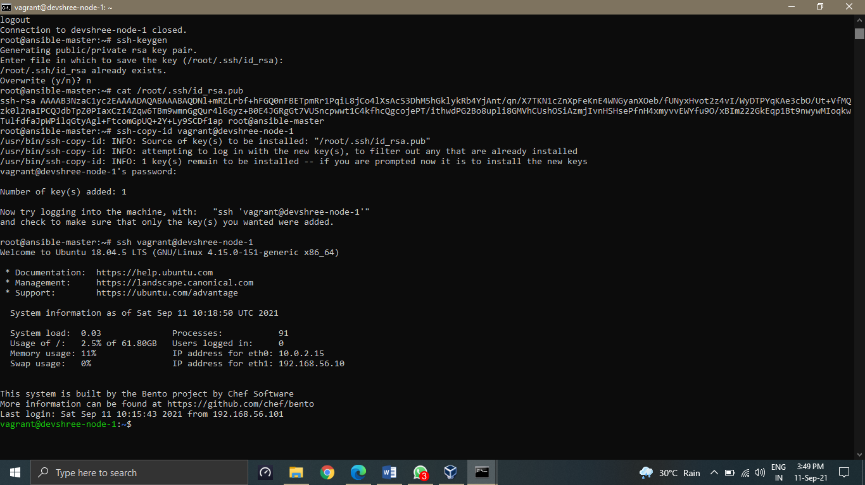

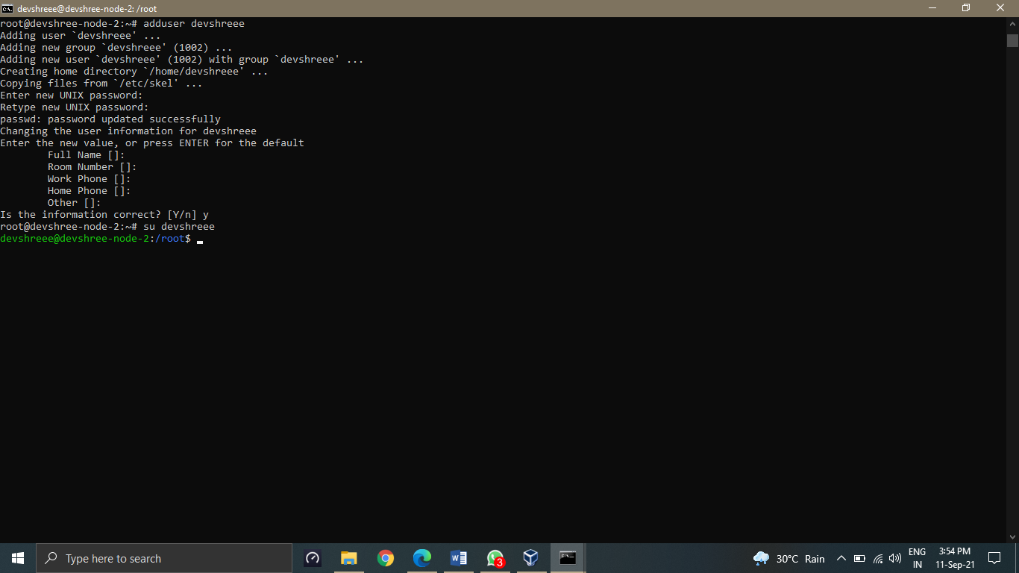

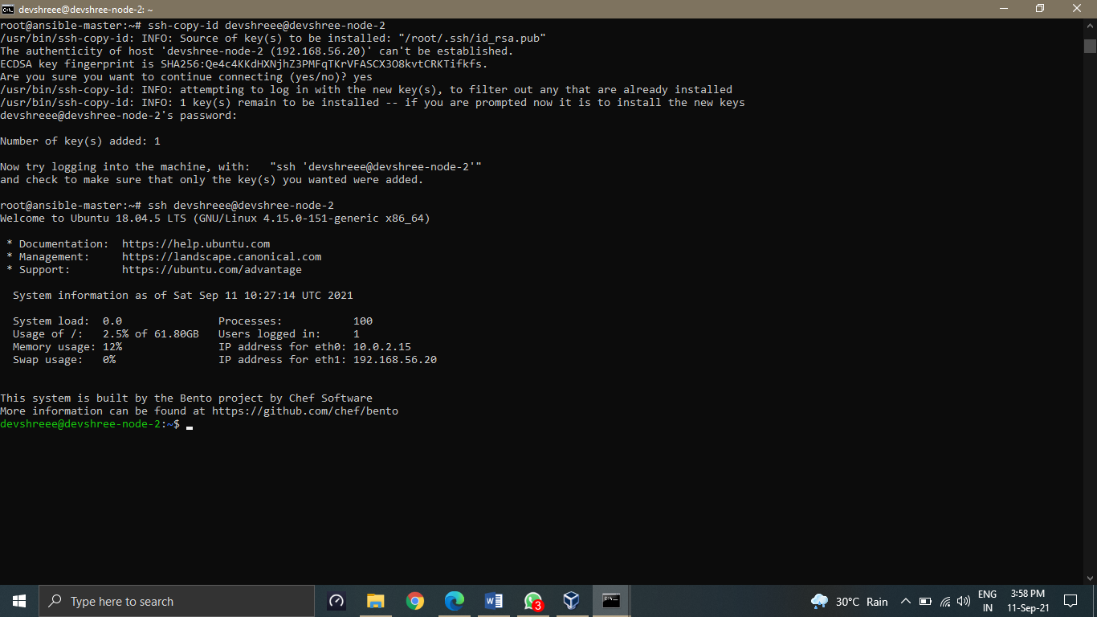

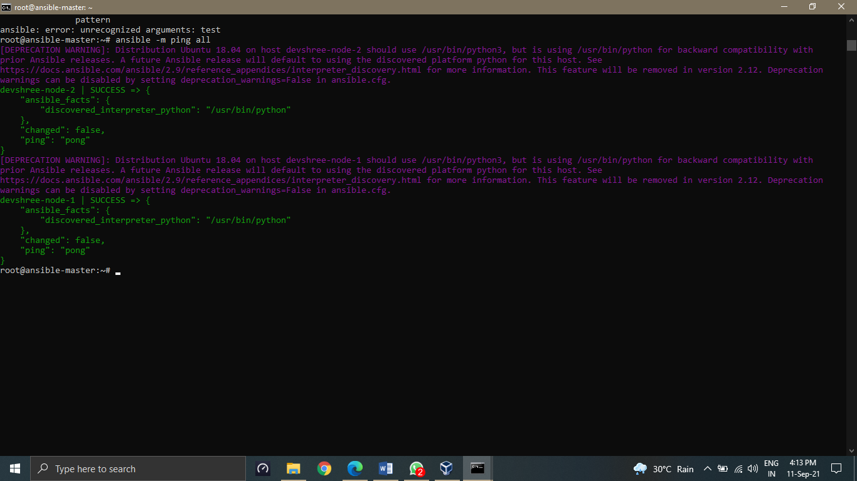

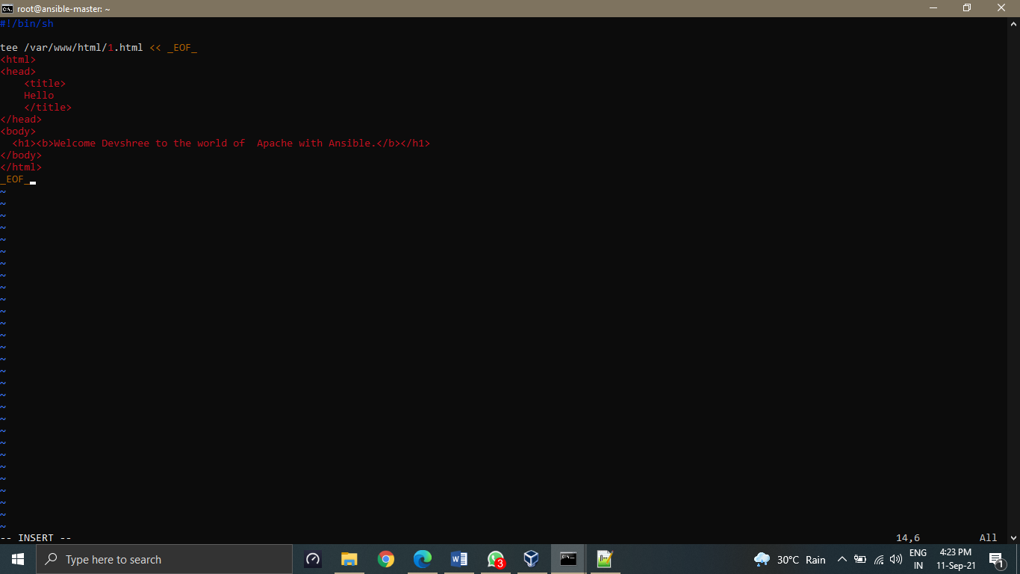

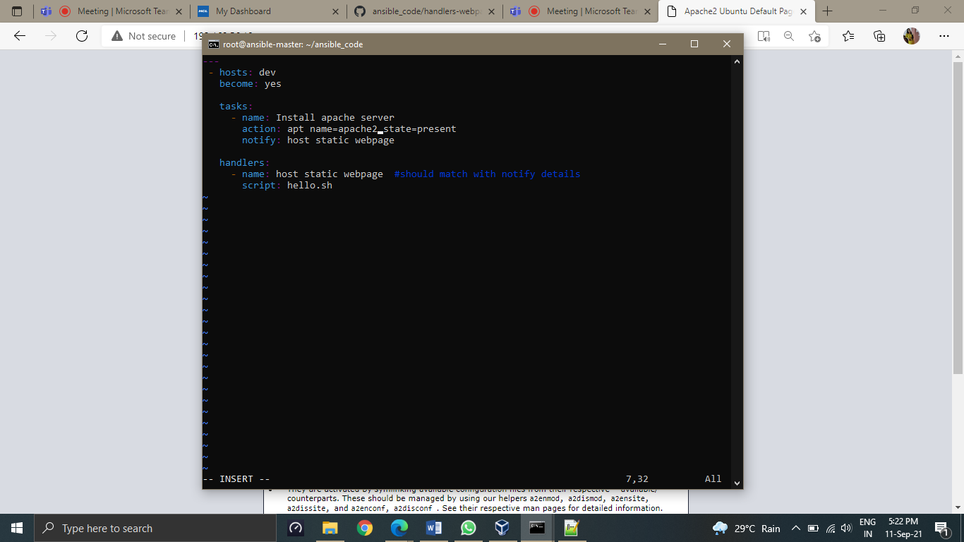

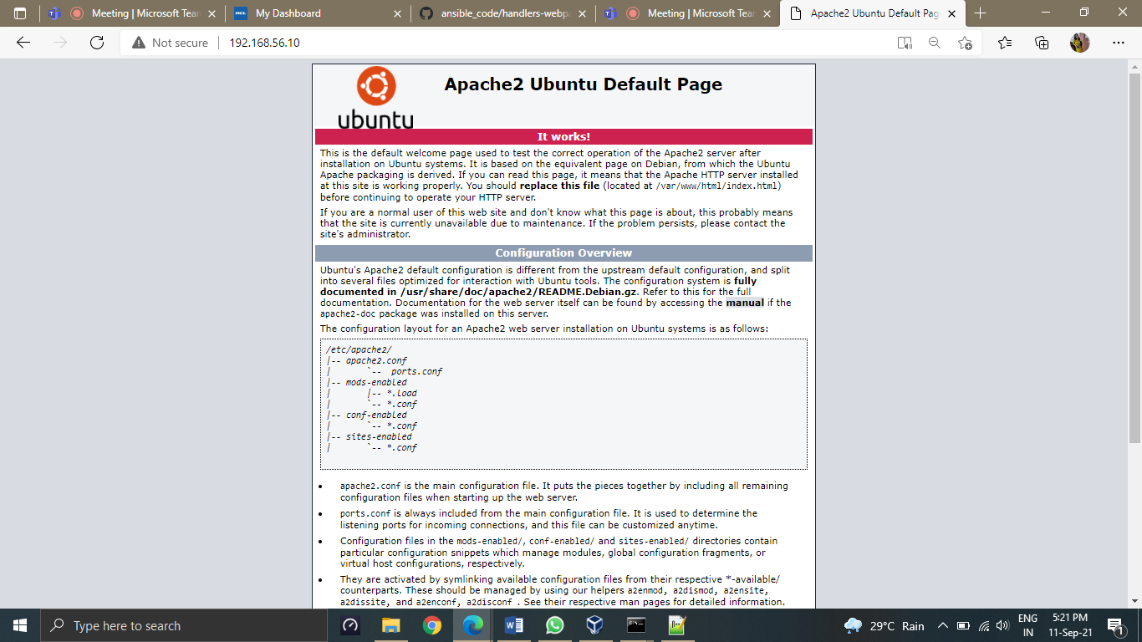

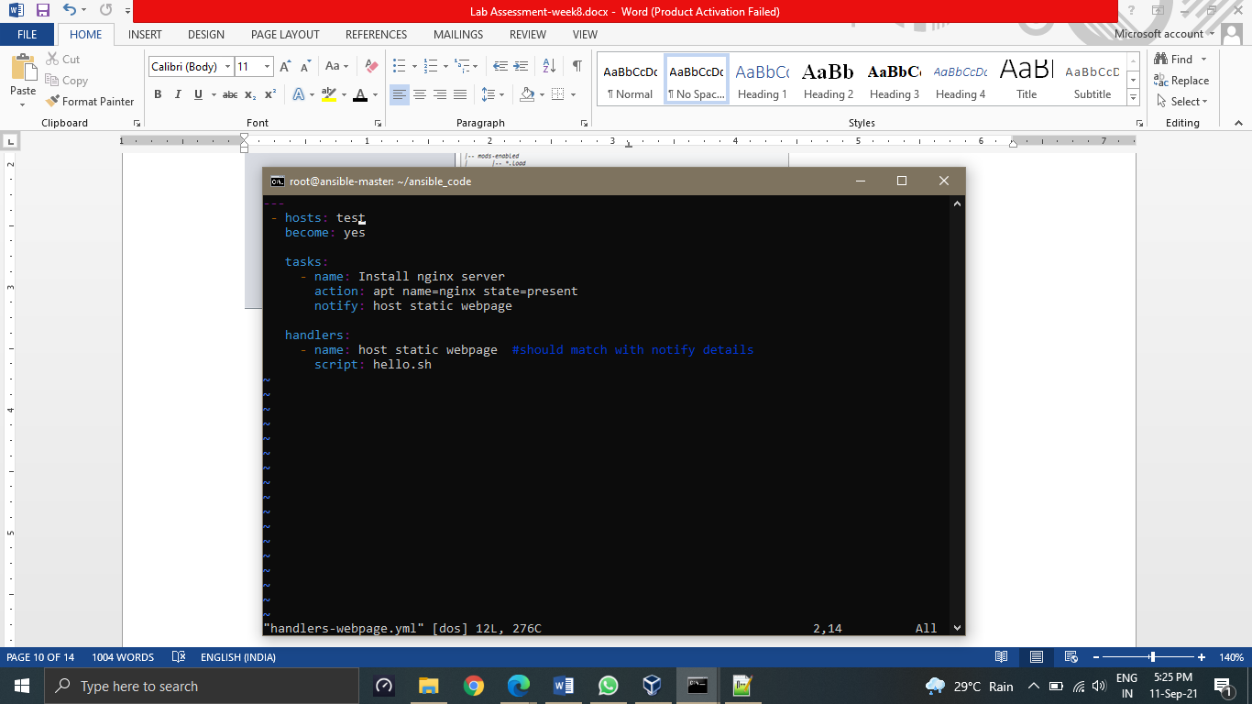

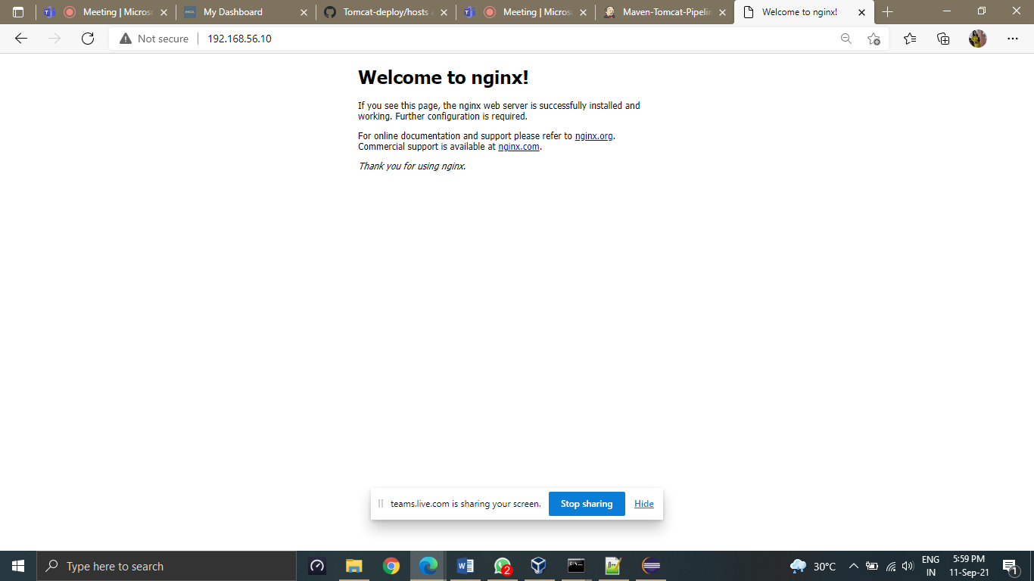

**Assignment-3**

Create a maven-based Java project and deploy it to tomcat container.

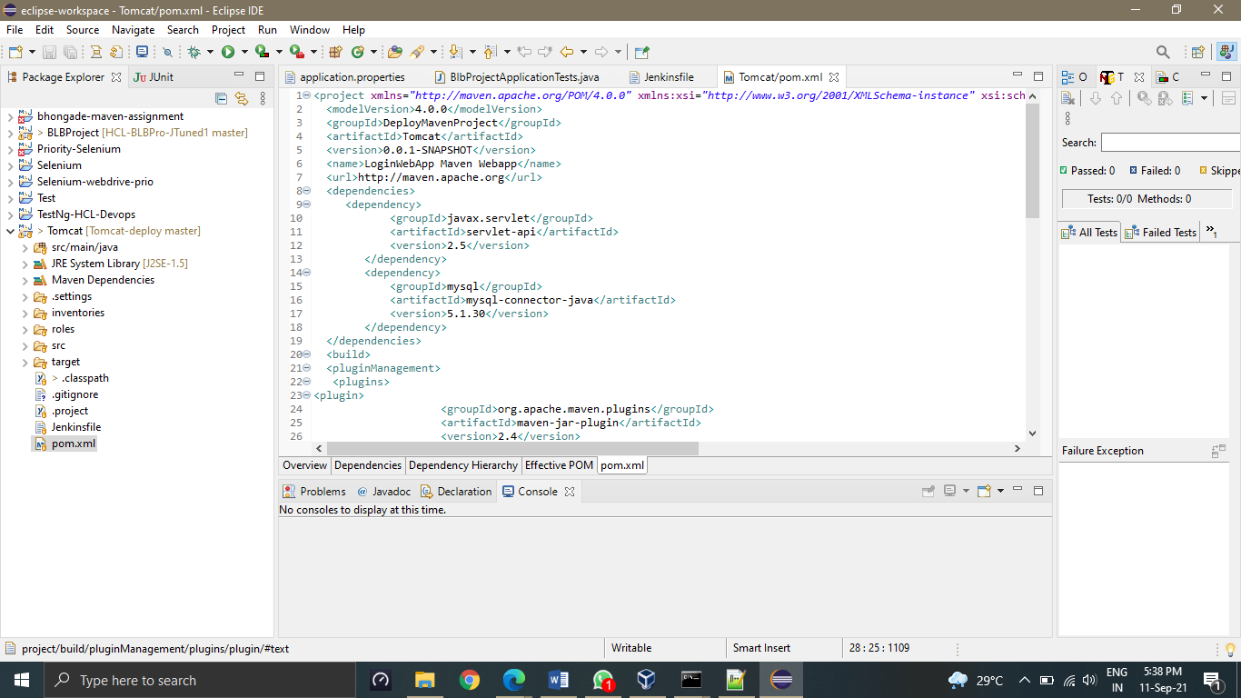

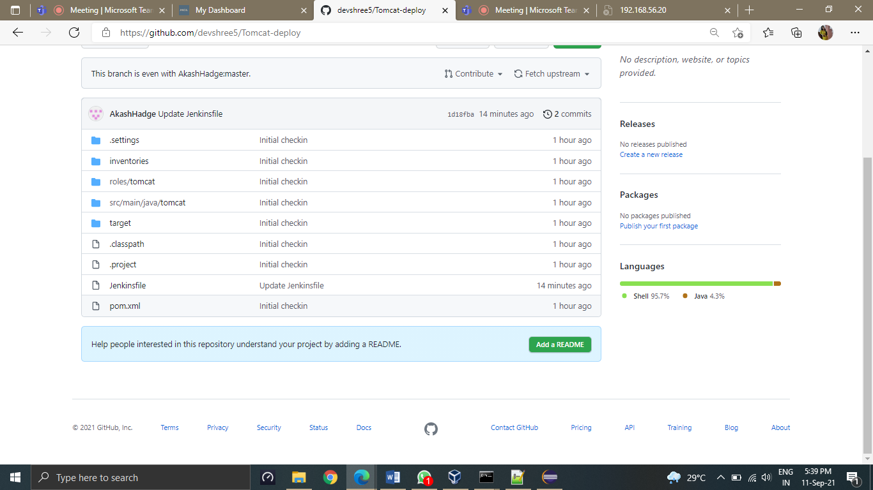

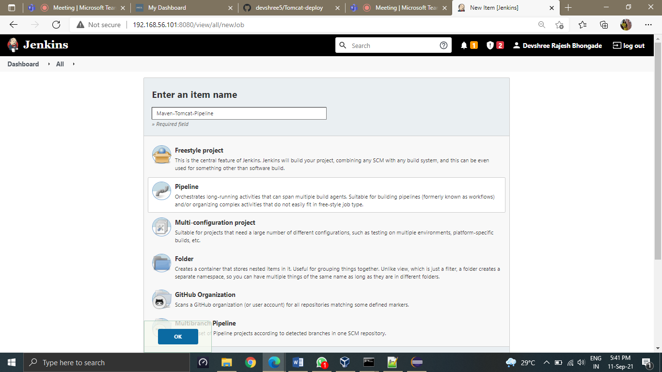

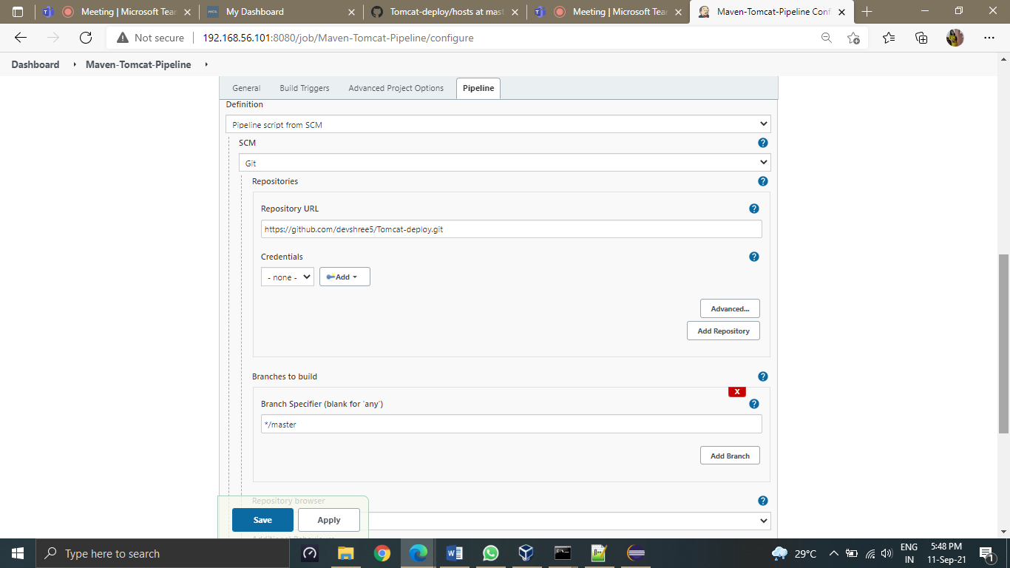

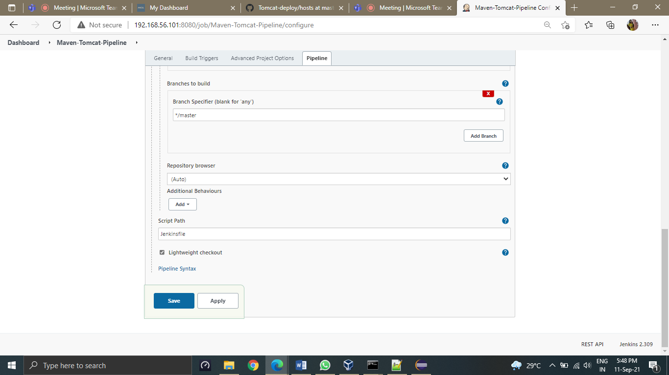

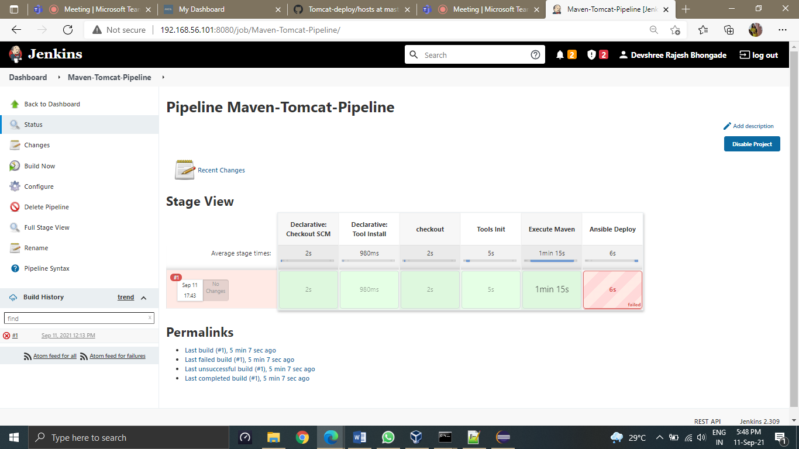

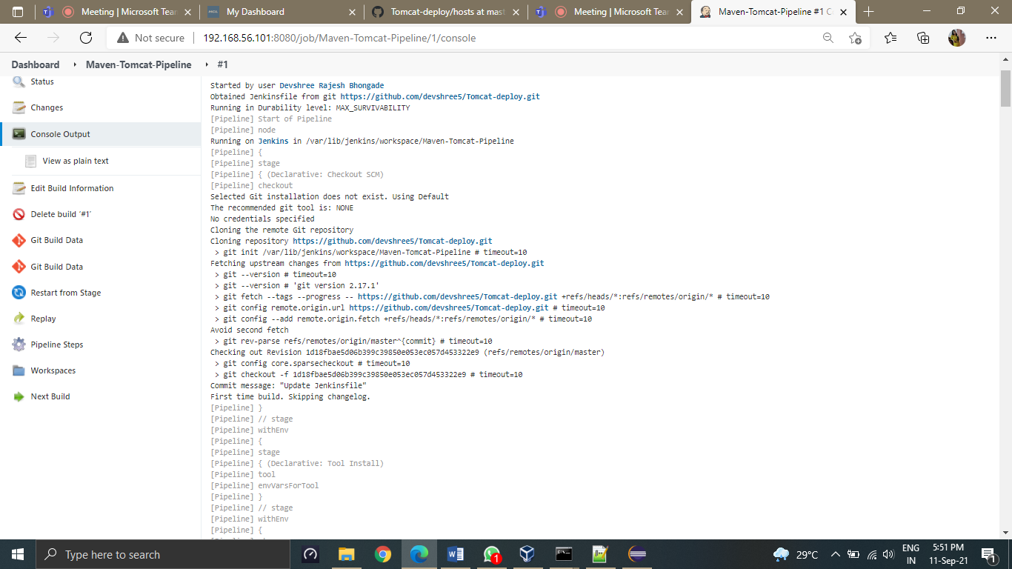

**ASSIGNMENT-4**

1. Delete all the existing docker images on your machine.
2. Pull ubuntu 20.04 image from docker hub.
3. Take the backup of this image on your machine and delete this image.
4. Restore the image from backup
5. Run it in an interactive mode and exit.
6. Create a new container and run it in detached mode and login to this container.
7. Create a file “puneet-assessment8.txt” using vi editor inside the container and with the contents "Welcome Puneet to assessment 8".
8. Exit from the container and stop it.
9. Restart the container and login to it.
10. Display the contents of “puneet-assessment8.txt” file.
11. Exit from container.
12. Clean up you machine by deleting all the containers and images.

**NOTE: Please prepare the document by capturing the screenshots of required outputs for each assignment for review.**

